Write a c program to find absolute value of given no [ Always +Ve ].
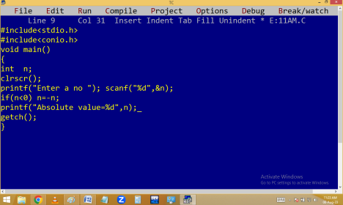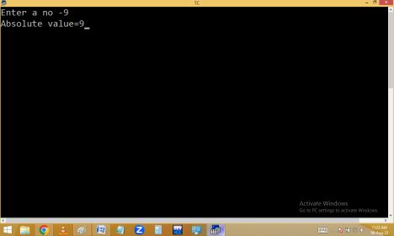
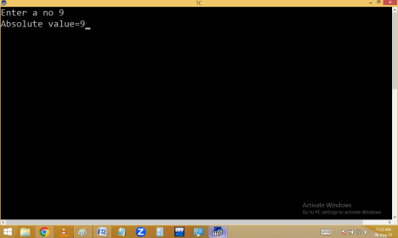Using abs():
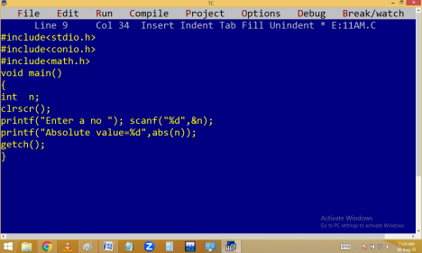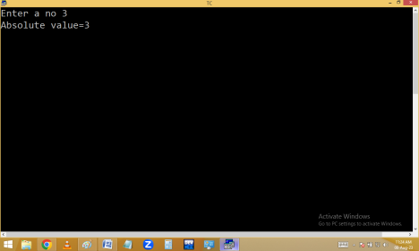
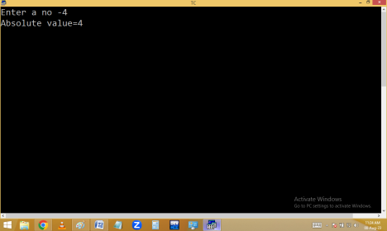Write a c program to print 1..10 numbers without using loop.
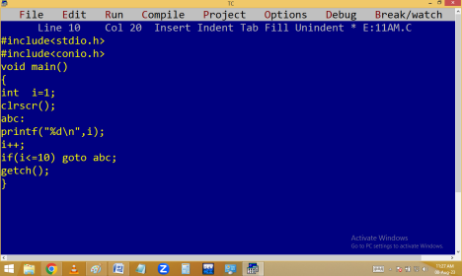
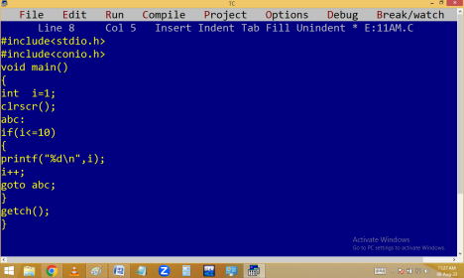
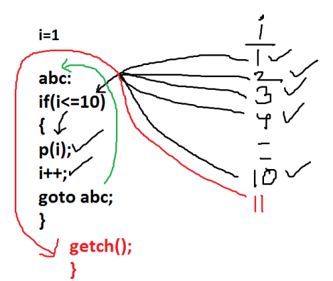Eg. Finding lower case alphabet or not.
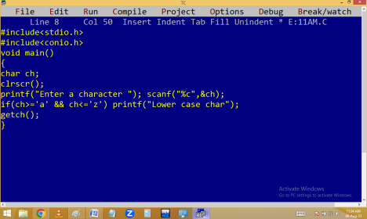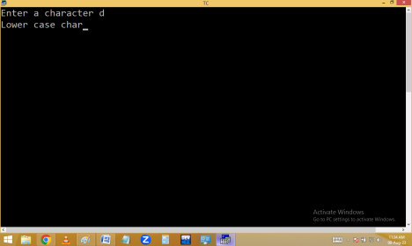
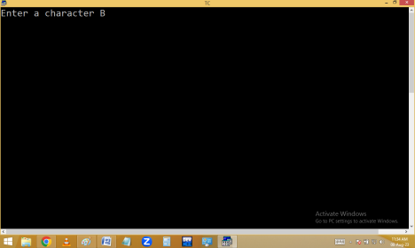
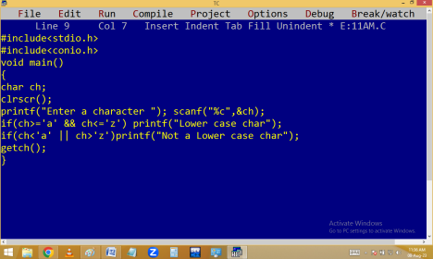
if..else: when the program is having 2 options then go for if..else.
if condition true statements in if block { } are executed and else not considered.
If condition false statements in else block { } are executed. Else doesn’t require any condition.
Syntax:
Finding lower case char using if..else:
Eg. finding upper case char or not.
Using ascii values:
Finding it is a special char or not.
Finding two digit no or not.
Eg. Finding voter eligibility.
Eg. Finding Even/Odd
Without % operator:
Without using arithmetic operators:
Finding leap year / Common year.
Eg. Currency denomination
888 Rs
888/500=1 – 500 Note
888%500=388 388/200=1 – 200 388%200=188 188/100=1 – 100 188%100=88
88/50=1 – 50 88%50=38
38/20=1 – 20 38%20=18
18/10=1 – 10
18%10=8
8/5=1 – 5
8%5=3
3/2=1 – 2
3%2=1 - 1

